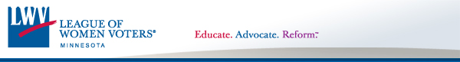

League of Women Voters Council of Metropolitan Area Leagues (CMAL)

Winter Quarterly Meeting - Saturday January 19, 2013

9:30 - 10:00am Coffee & treats
10:00 - 11:45am Speakers & Q & A
11:45 - 12:00pm Announcements

At Richfield High School District Office, 7001 Harriet Ave. S

Our topic is:

Communities for a Lifetime
Certain projects have been designed, funded and implemented to improve the lives of designated groups of people. We learned at our last meeting the Twin Cities Metropolitan Area is experiencing a shift in demographics to the graying of the area. By the year 2030, one in four Minnesotans will be over age 65.

Our speakers will be:
Beth Wiggins who has worked with the DARTS Program in Dakota County which provided “Outdoor Chore and Home Maintenance for Seniors” and how it fit into Communities for a Lifetime.
Julius Smith, who served on the Met Council for over 15 years, will talk about the first “planned town” in MN developed with Federal funds and the McKnight Foundation. The town of Jonathan in Carver County was designed to meet the needs of new residents for housing and access options for shopping, working, etc. Mr. Smith will share lessons learned and future possibilities.

The Public is welcome.

Contact: Geneva MacMillan, 952-934-3000

